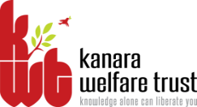
KANARA WELFARE TRUST’S
DIVEKAR COLLEGE OF COMMERCE
KARWAR – 581301 (UTTARA KANNADA)
NAAC Re-accredited- B Grade
-08382-225221
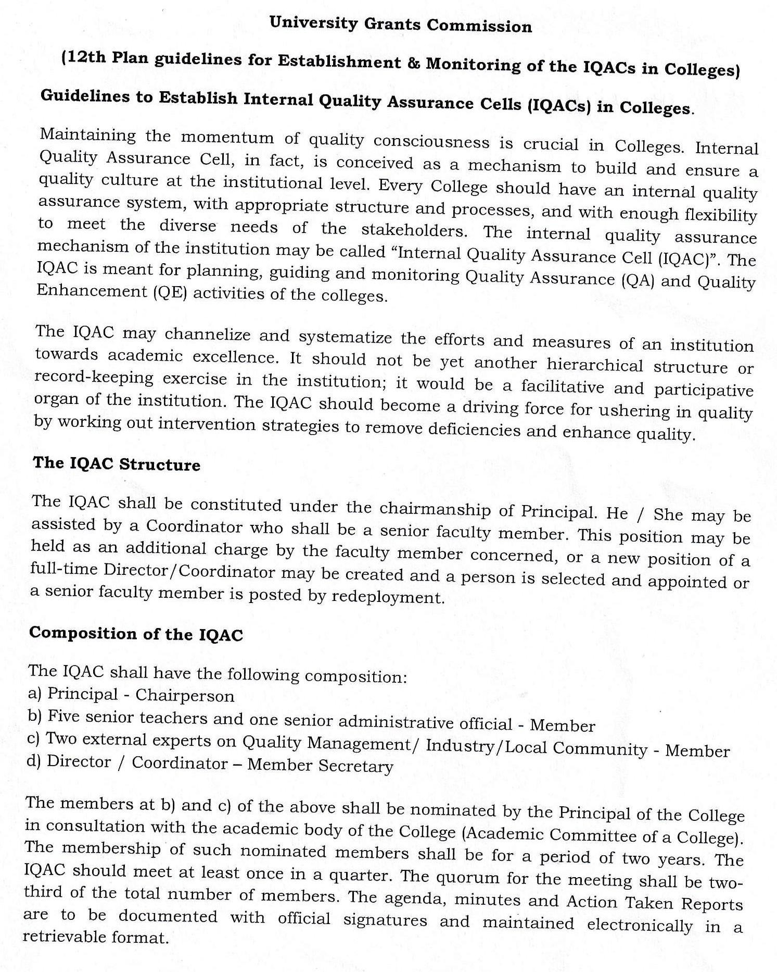
email:-kwtdcckarwar@gmail.com

A meeting of IQAC was convened on 2nd July, 2015 in the principal chamber. The principal directed to composition of the IQAC committee for the year 2015-16 as follows.

MEMBERS OF THE IQAC COMMITTEE 2015-16

SL.No | Name | Role in IQAC | Designation
 | Prin. Dr.M.H.Naik | Chairperson | Principal
 | Prof. C.D.Bhat | Coordinator | Associate Professor in Commerce
 | Dr. Keshava K.G | Joint Coordinator | Asst. Professor in Commerce
 | Prof. S.N.Dafedar | Member | Lecturer in Commerce
 | Prof. M.V.Bhat | Member | Associate Professor in Commerce
 | Prof. N.S.Agali | Member | Associate Professor in Commerce
 | Sri. Satish Gunagi | Member, College Administration ber | Office Superintendent
 | Sri. K.V. Shetty(A.O., KWT) | Member K.W.T. | Trustee-Secretary, Kanara Welfare Trust, Ankola
 | Shri. Ganapati Hegde | Member, Alumnus | Chartered Accountant
 | Sri. Nazeer Shaikh | Member, Alumnus | Social Worker, Azad Youth Club, Karwar
 | Sri. Ajay Shetty | Member, Alumnus | Industrialist
 | Kum. Pooja Dhood | Member | Student
 | Mr. Sankalp Shanbhag | Member | Student
