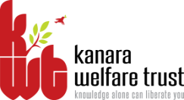
KANARA WELFARE TRUST’S
DIVEKAR COLLEGE OF COMMERCE
KARWAR – 581301 (UTTARA KANNADA)
NAAC Re-accredited- B Grade
-08382-225221
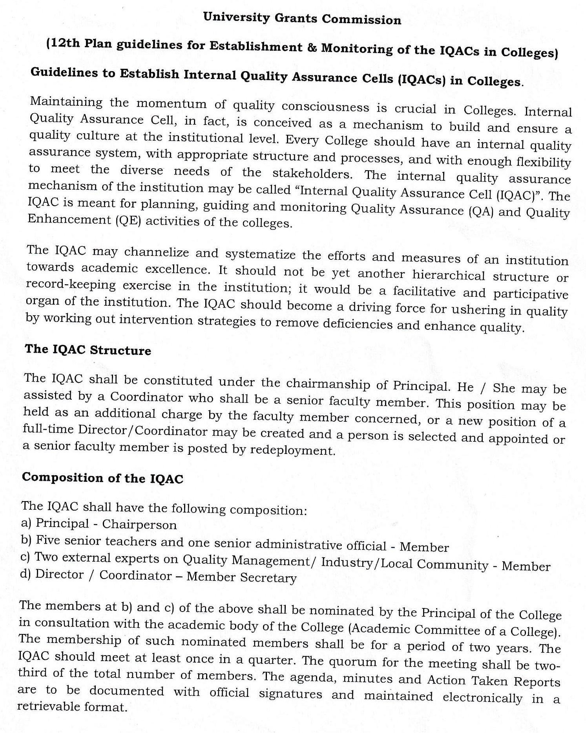
email:-kwtdcckarwar@gmail.com

A meeting of IQAC was convened on 13th July, 2017 in the principal chamber. The principal directed to composition of the IQAC committee for the year 2017-18 as follows.

MEMBERS OF THE IQAC COMMITTEE 2017-18

SL.No | Name | Role in IQAC | Designation
 | Prin. Dr.B.H.Nayak | Chairperson | Principal
 | Prof. S.N. Dafedar | Coordinator | Associate Professor in Commerce
 | Dr. Keshava K.G | Member | Asst. Professor in Commerce
 | Prof. Nitin S. N. | Member | Lecturer in Commerce
 | Sri. SatishGunagi | Member, College Administration ber | Office Superintendent
 | Sri. K.V.Shetty(A.O., KWT) | Member K.W.T. | Trustee-Secretary, Kanara Welfare Trust, Ankola
 | ShriGanapatiHegde | Member, Alumnus | Chartered Accountant
 | Sri. NazeerShaikh | Member, Alumnus | Social Worker, Azad Youth Club, Karwar
 | Sri. Ajay Shetty | Member, Alumnus | Industrialist
 | Nagaraj Naik (Student) | Member | Student
 | Shubhangi Bhat(Student) | Member | Student

PRINCIPAL
