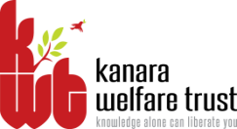
KANARA WELFARE TRUST’S
DIVEKAR COLLEGE OF COMMERCE
KARWAR – 581301 (UTTARA KANNADA)
NAAC Re-accredited- B Grade
-08382-225221 email:-kwtdcckarwar@gmail.com
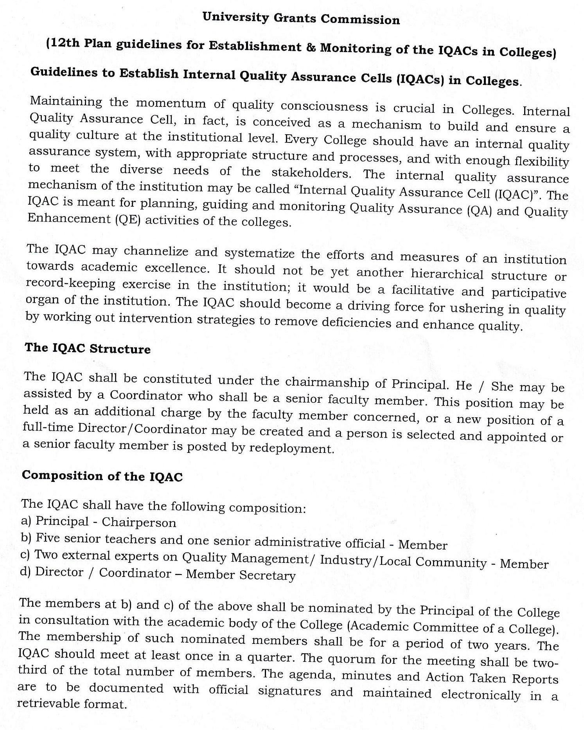
Website:- www.divekarcollege.ac.in

A meeting of IQAC was convened on 20th July, 2019 in the principal chamber. The principal directed to composition of the IQAC committee for the year 2019-20 as follows.

MEMBERS OF THE IQAC COMMITTEE 2019-2020

S.No | Name | Role in IQAC | Designation
1 | Prin. Dr. Keshava K.G. | Chairperson | Principal
2 | Dr. B.R. Tole | Members from Teaching Faculty | Physical Director
3 | Smt. Pooja Naik |  | Lecturer in Computer Science.
4 | Ms. Reevon Rebello |  | Lecturer in Commerce
5 | Smt. Nusrat Khan |  | Lecturer in Commerce
6 | Shri. Shridhar Nayak |  | Lecturer in English
7 | Shri. Krishnanand Mahale |  | Lecturer in Commerce (M.Com)
8 | Shri. Sateesh Gunagi | Member, College Administration | Office Superintendent
9 | Shri. K.V.Shetti | Member KWT. | Trustee-Secretary, Kanara Welfare Trust, Ankola.
10 | Shri Ganapati Hegde | Member, Alumnus | Charted Accountant
11 | Shri. Nazeer Shaikh | Social Worker, Alumnus | Azad Youth Club Karwar
12 | Shri. Ajay Shetty | Industrialist, Alumnus | U.K Pickles, Karwar
13 | Shri. Suresh B. Gudimani | Coordinator | Librarian
14 | Shri. Sudheer Kadam | Joint Coordinator | Lecturer in Commerce
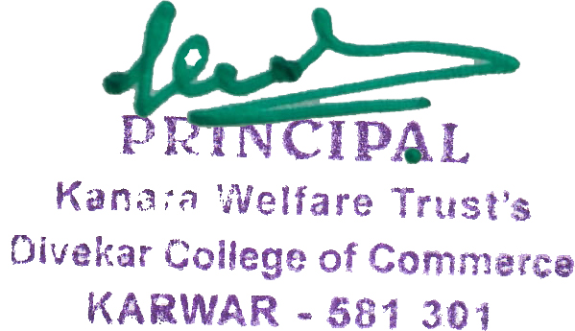

Principal

