KANARA WELFARE TRUST’S
DIVEKAR COLLEGE OF COMMERCE
KARWAR – 581301 (UTTARA KANNADA)
NAAC Re-accredited- B Grade
-08382-225221 email:-kwtdcckarwar@gmail.com
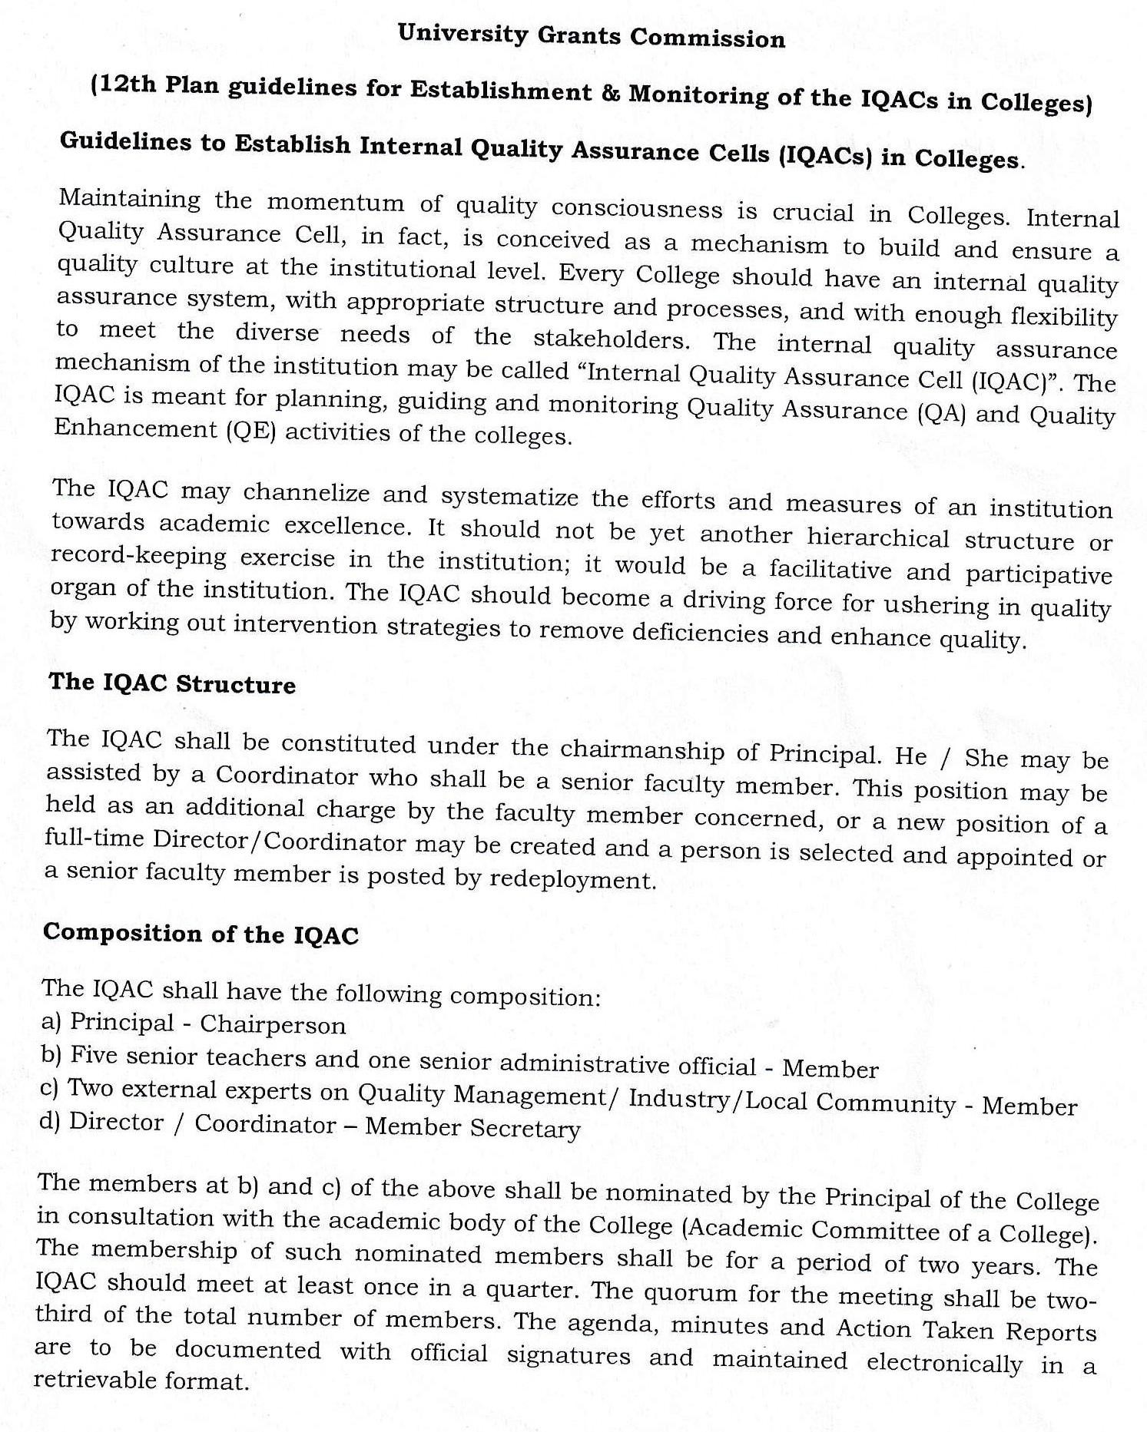
Website:- www.divekarcollege.ac.in

A meeting of IQAC was convened on 21th November,, 2020 in the principal chamber. The principal directed to composition of the IQAC committee for the year 2020-21 as follows.

MEMBERS OF THE IQAC COMMITTEE 2020-21

SL.No | Name | Role in IQAC | Designation
 | Dr. Keshava K.G. | Chairperson | Principal
 | Shri. Sudheer Kadam | Coordinator | Lecturer in Commerce
 | Shri. Shubham Talekar | Joint Coordinator | Lecturer in Commerce
 | Dr. B.R. Tole | Member | Asst. Physical Director
 | Shri. Suresh B. Gudimani | Member | Asst. College Librarian
 | Dr. Harish Kamat | Member | Lecturer in Computer Sci.
 | Ms. Nutan Majalikar | Member | Lecturer in Commerce
 | Smt. Priyanka Tarikar | Member | Lecturer in Commerce
 | Smt. Sandhya Kadam | Member | Lecturer in Hindi
 | Shri. Sateesh Gunagi | Member, College Administration | Office Superintendent
 | Shri. K.V.Shetti | Member K.W.T. | Trustee-Secretary, Kanara Welfare Trust, Ankola.
 | Shri Ganapati Hegde | Member, Alumnus | Chartered Accountant
 | Shri. Jeetendra Tanna | Member, Alumnus | Businessman,Shreeji Electronics, Karwar
 | Shri. Nazeer Shaikh | Member, Alumnus | Social Worker, Azad Youth Club, Karwar
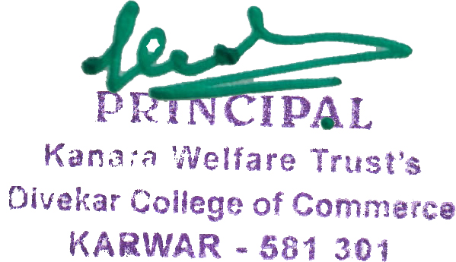

Primcipal

